AXiS-64 Firmware Updater

Introduction

The AXiS-64 firmware is updated using serial over USB. This is done using the AXiS-64 Firmware
Updater software which needs to be set up for your computer. Once you have completed the set-
up, the software will be on your computer and any future firmware updates are easy.

There are two stages to setting up the Firmware Updater for your Mac.
1. Install the Serial Driver.
2. Install the Firmware Updater.

1. Installing the Serial Driver.
The driver you'll need is in the "MAC Install Me First" folder in:
http://www.c-thru-music.com/support/AXiS-64/Firmware_Updater/Mac/
o Using your browser, download the correct driver according to your operating system.
o (To check which OS you have, look under the Apple Menu "About this Mac".)
o NOTE: If the .dmg file displays in your browser instead of downloading, use Ctrl-Click or
"Save Link As.." option to save it to your desktop.
o Double Click the .dmg file on your desktop. A disk image will appear on your desktop.
o If a window does not open, open the disk image (double-click)
o Double-click the .pkg file and follow the instructions to install the driver.
o Restart your Mac.
2. Installing the Firmware Updater.
o Download ‘AXiS 64 Firmware Updater- Mac.zip’.
o Un-Zip (double-click or use Stuffit Expander).
o Open the ‘AXiS 64 Firmware Updater- Mac‘ folder.
Which Updater shall I use?
o From the Apple menu in the top left corner of your screen, select ‘About this Mac’ – this will
open a window showing which Mac OS X version you have.
o If you have version 10.3.9 or above, use AXiS-64 Firmware Updater Universal.pkg
o If you have version 10.3.8 or below, use AXiS-64 Firmware Updater Power PC.pkg.
To install your AXiS-64 Firmware Updater double click the relevant .pkg file.

o Follow the on screen instructions.
o Once installation is complete, the AXiS-64 Firmware Updater software can be located in
you Applications folder.

Setting up the USB port in OS 10.4
Skip this step if you have MacOS 10.5 or above.
o Plug your USB cable into your computer and the AXiS-64.
o Go to the apple menu and open system preferences.
o Select ‘Network’
o You will see the following pop up window.

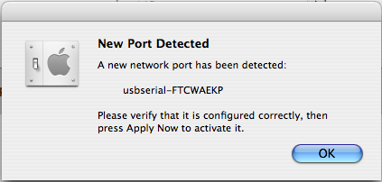

o Click OK.
o From the ‘Show’ drop down menu, select ‘Network Port Configurations’
o Tick the usbserial option as below.
o Click ‘Apply Now’.

Running the AXiS-64 Firmware Updater

WARNING: If the USB cable connecting your computer to the AXiS becomes disconnected during firmware update, although unlikely, it is possible that AXiS will not only lose the firmware but the ability to load new firmware. AXiS would then become useless and this cannot be rectified without returning it to the factory.
(Updating firmware usually takes less than one minute).

o Ensure the AXiS-64 is powered up and connected to your Mac.

o Double click on AXiS-64 Firmware Updater.app.
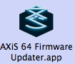

o You will be presented with this settings window.
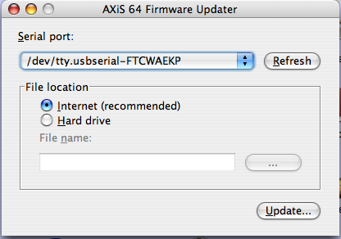

o Ensure the usbserial port is selected as above.

o Select the File location of the firmware file ...
Internet (recommended)

o Selecting this option will get the latest firmware direct from the C-Thru Music website.

Hard Drive
o Selecting this option allows you to access the firmware file from the hard drive or external
media connected to the machine.
o Click the ‘....’ Browse button, navigate to where you have the firmware zip file stored and
select it.
o Click ‘Open’

Updating the Firmware

o Click ‘Update’
o The update window will open and you can monitor the progress from the progress bar and
associated messages.
o For more detailed download information click ‘Advanced >>>’ for real-time messaging. This
window can be hidden by clicking ‘Basic <<<’.
o Upon completion, the LCD on the AXiS –64 will display the version number of the firmware.
You may close/quit the programme.

